ADVANCED SOFTWARE SERVICES, INC.
WORK IN PROCESS USER MANUAL

Title Page

Table of Contents 1
General System Keyboard Functions 2
Work in Process Inventory Overview 3
WIP TAG Maintenance Browser 34
WIP TAG Maintenance
WIP TAG History Browser
WIP TAG History Maintenance
WIP Warehouse / Bin Maintenance 34

FUCTION KEYS

The following describes the standard function keys:

BRWS = The browser which is a list of records in the file. This is functionally equivalent
to the find option of our standard package.

VIEW = View record provides the ability to ADD, CHANGE, DELETE and UPDATE
an individual record.

SORT BY = The selections at the bottom of the browser which will sort the list in alphabetic order.
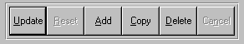
Update = Updating the current record.
Reset = Reset the current record.
Add = Add a record.
Copy = This will copy the existing record.
Delete = Delete the current record displayed on the screen.
Cancel = Canceling the information that was entered.
Save = Save the record


Takes you to the first record. | Takes you back one record at a time. | Moves forward one record. | Last current record.
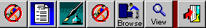

Search F3 | List F3 | Notes F4 | Misc. Fields F1 | Brows F6 | Viewer F7 | Exit F12

ADVANCED SOFTWARE FUNCTION KEYS

The following describes the standard function keys:

Next Shows the next sequential record.

Prev Shows the previous record.

Add Add a record.

Change Change the current record displayed on the screen.

Delete Delete the current record displayed on the screen.

Find Find a record by searching by description.

1 2 Number 1, 2 to go the page of this record.

Esc Escape from the current transaction without updating.

Q Quit from the current transaction without updating.

F1 Save

F3 Help information is available on every data field. Simply place the cursor on a field and press F3 to display documentation regarding this particular field.

F3 To insert additional data in a data field without erasing the information currently displayed.

F4 Notes general

F1 Field Lookup is available on every data field which is maintained in a separate file. Place the cursor on a field and press F1 to search for the code by description or to advance a screen of records by pressing the next key. Place the cursor next to the desired record and press enter to transfer the record to the data entry screen. See Page up / down keys below as an alternative.

F7 Delete

F8 Notes file specific

Enter Advances the cursor to the next field.

Page Up/ Page up / down keys will skim through each record in a data file in sequential order. For
Down small files, this may be faster that the searching the file with the F1 key.

WORK IN PROCESS INVENTORY OVERVIEW

Work in Process, known as WIP is best known as raw materials with conversion costs added. This inventory is no longer raw material but not yet finished goods. The value and location of WIP is the esstential to month end accounting and plant productivy. The purchase of the Advantzware WIP software is to track the location of each bar coded pallet produced from one machine to the next. WIP inventory control starts with incoming rolls or sheets. The raw material will have a bar code for each roll or pallet of sheets. Once the first machine operation occurs, the raw material tag will become one or more WIP tags. For example, a roll of paper will have a single roll tag that may consist of 20,000 lineal feet. Once converted, this may become three WIP tags, therefor the WIP tag creation screen will allow the operator to defined the raw material tags consumed, the quantity of sheets per pallet and location of each WIP tag. The software will automatically create sequentially numbered WIP tags and a WIP text file that is used to print the WIP tag via the Lable Matrix software. The N-K-1 WIPTAG parameter is used to dictate the location of the Text file as well as the name and location of the file name to be used by the Label Matrix software.

The value of WIP equals the total cost of each raw material plus the cost of each machine and labor transaction minus the value of finished goods received. Raw material issues of paperboard, inks, glues, pallets and other materials add to the total cost of WIP Material costs. The job’s WIP Labor costs are added via data collection transactions as the job progresss from cutting to printing to finishing. The J-R-12 WIP by product category report provides the value of WIP for all open jobs as of the last day of each month. Please note, closed jobs will have zero WIP value since closed jobs will have become finished goods. If a job is partial completed, the report will reduce the value of WIP by the value of finished goods received based on the jobs standard costs of material and labor. The jobs standard cost is based on estimated material and labor costs for each specific job quantity. However the report uses actual raw material costs based on purchased cost of that material issued to the job. Labor costs applied to WIP is both actual man hour costs form Touch Screen data collection and actual machine hours times overhead rates defined in the machine file.

WIP WAREHOUSE/BIN LOCATION

Multiple locations may be defined for each company. Once defined, the location code is used to define the WIP warehouse and bin location of each WIP Tag. WIP warehouse and bin locations must be created in the folder on theAdvantzware menu keys J-F-4 warehouse file maintenance. Once defined, the WIP Tag reporting will require entry of the location of the WIP tag.

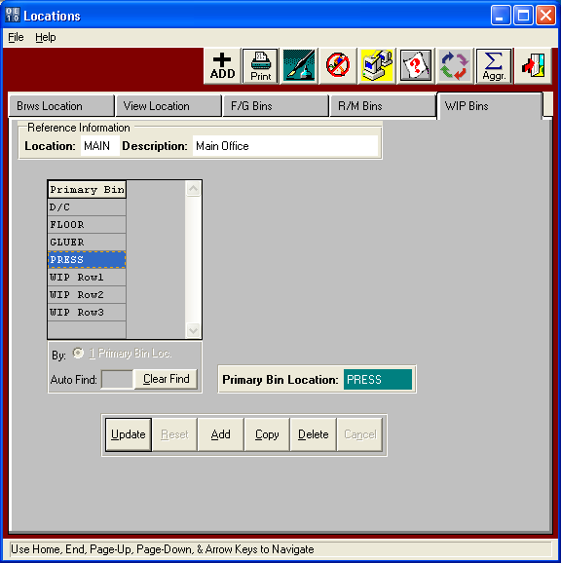

Location - (5) Alphanumeric characters. Enter the Plant, or the Warehouse, code so that we can track (control) inventory for this location.

Description - (15) Alphanumeric character. Enter a description for this warehouse.

WIP TAG FILE MAINTENANCE- BROWSE

Work in Process Browser allows searching WIP Tags by tag number, raw materials warehouse, bin location, raw material item code, item name or finished goods item code or name. Selecting a specific WIP will will then show the detail history of the WIP tag including location and details of each conversion process.

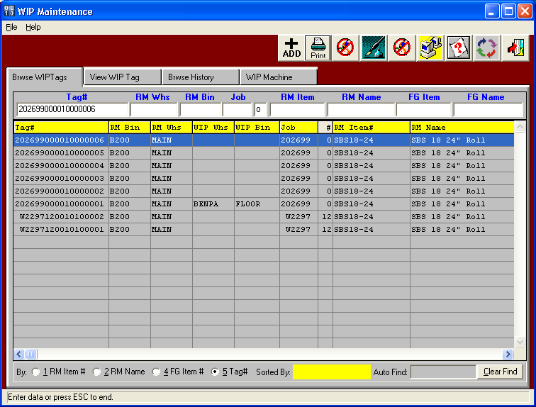

WIP TAG FILE MAINTENANCE- VIEW

Viewing a Work in Process tag shows the raw material tag number used to create this WIP tag, the job and finished goods item code that is being procuded. Data from the raw material tag shows the raw material item code, name, sheet size and original locatioin of the converted raw material tag. This screen also shows the lastest information of the WIP including the location, converting machine, job number, form number, finished goods item code and sheets converted.

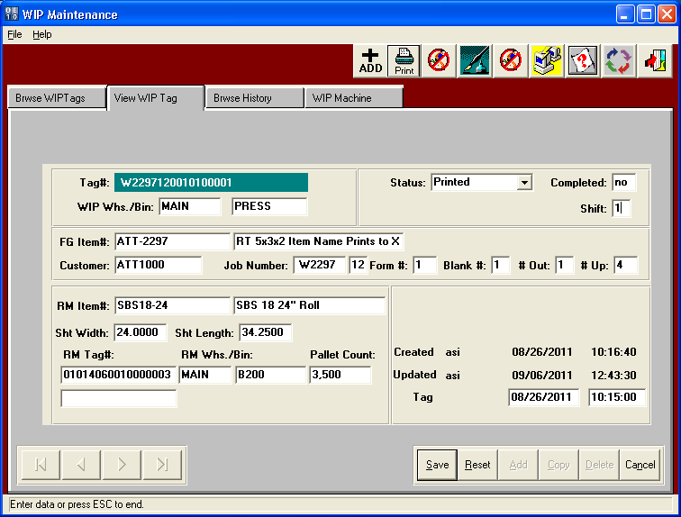

WIP TAG FILE MAINTENANCE- BROWSE HISTORY

WIP Machine file shows the details of the WIP tag for this specific WIP Tags including the converting machine, WIP locaction and number of sheets on this WIP tag.

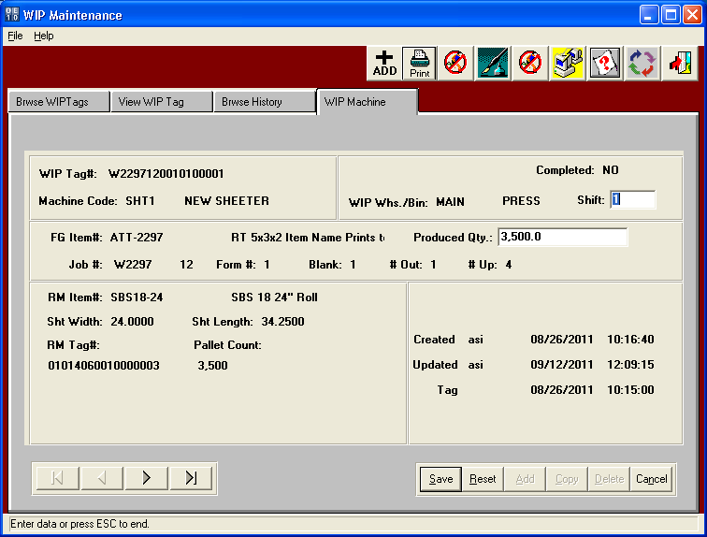

WIP TAG CREATION (J-U-3)

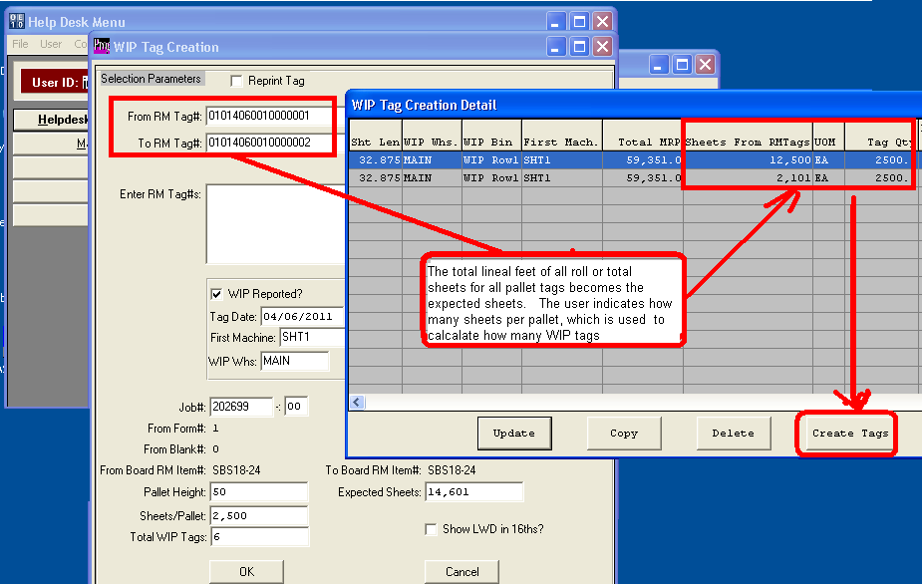

The purchase of the Advantzware WIP software is to track the location of each bar coded pallet produced from one machine to the next. WIP inventory control starts with incoming rolls or sheets. The raw material will have a bar code for each roll or pallet of sheets. Once the first machine operation occurs, the raw material tag will become one or more WIP tags. For example, a roll of paper will have a single roll tag that may consist of 20,000 lineal feet. Once converted, this may become three WIP tags, therefor the WIP tag creation screen will allow the operator to defined the raw material tags consumed, the quantity of sheets per pallet and location of each WIP tag. The Job number and Form number is used to determine the sheet size needed which is used to calculate the expected number of WIP Sheets. For example if a sheet length is 36 inches (3 Feet) and a roll is 21,000 feet, then there would be 7,000 sheets. Once the first machine such as a slitter or sheeter cuts the paperboard, the machine operator or forklift driver will scan the raw tag and enter the number of sheets per pallet and next location of the WIP Tag. This data is exported to the worksheet to make any last minute changes to pallet counts.

The CREATE Tags button will automatically create sequentially numbered WIP tags and a WIP text file that is used to print the WIP tag via the Lable Matrix software. The N-K-1 WIPTAG parameter is used to dictate the location of the Text file as well as the name and location of the file name to be used by the Label Matrix software.

WIP TAG CREATION FIELDS

From RM Tag - Enter or scan the first raw material roll tag or pallet tag.

To RM Tag - Enter or scan the first raw material roll tag or pallet tag.

RM Tags - Enter or scan, each raw material roll tag or pallet tag separated by a comma.

WIP Reported - Click this toggle box to enter the work in process transaction. This will be used when creating WIP tags on the plant floor. If WIP tags are created in the office, the WIP data will not be known, therefore this toggle box will not be checked. The program will simply be used to create the WIP tag labels to be used during the WIP production reporting via the J-U-4 Assign WIP Tags to Machine.

Tag Date - Enter the date the WIP tag was created.

First Machine - Enter the machine code used in production for this Raw Material tag.

WIP Whse - Enter the WIP warehouse locaton that the WIP tag will be located. Work in Process warehouses and bin locations must be defined in the J-F-4 Warehouse / Bin locations. The WIP warehouse should match and normal plant location, however, the bin location may be a physical rack or warehouse location or may be a machine. A bin loction for WIP may be an isle, rack, floor location or machine description such as PRESS, DIECUTTER, GLUER and an exact machine code. WIP reports will print the location of the WIP tag based on the location defined.

Job# /Form# - The Job number and form number is used to determine the sheet size needed which is used to calculate the expected number of WIP Sheets. For example if a sheet length is 36 inches (3 Feet) and a roll is 21,000 feet, then there would be 7,000 sheets.

Raw Material - From and To Board Raw Material Item simply displays the actual board material for the raw material tags are are being converted. This serves as a reference so the operator verifies that he is using the correct board material.

Pallet Height - Enter the total pallet height to stack the sheets.

Expected Sheets - The Job number and form number is used to search the sheet size used to calculate the expected number of WIP Sheets. For example if a sheet length is 36 inches (3 Feet) and a roll is 21,000 feet, then there would be 7,000 sheets.

Sheets/Pallet - The operator can enter the exact number of sheets per pallets that are stacked on each pallet.

WIP Tags - Total number of WIP tags that will be created based on the total expected sheets that will be converted from the raw material tags. The expected shets is divided by the sheets per pallet to determine how many WIP tags will be created. This data is exported to the worksheet where the counts and locations may be changed.

ASSIGNING WIP TAGS TO MACHINES (J-U-4)

Processing WIP tags is peformed via the J-U-4 menu as each machine operation is completed for each WIP tag.
The operator or forklift driver will scan the WIP tag, select or scan the machine code, then select or scan the wip location and sheet count for that WIP tag.

